Lab56:
Create a scalar function to calculate the annual bonus for employees based on their salary.
1. create a scalar function:
Create a function CalculateBonus which will take @Salary DECIMAL(10, 2) as a parameter to calculate the bonus based upon the salary. This function returns a decimal value.
We need to pass this parameter while calling the function CalculateBonus.
AS keyword is used to define the function body here.
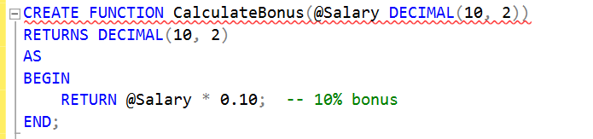
We can see the created scalar function here inside the function folder:
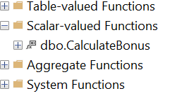

2. use the scalar function in a query:
Use the select query to retrieve the EmployeeID, FirstName, LastName, Salary from Employee table and a function CalculateBonus(salary), salary is passing as a parameter inside this function.
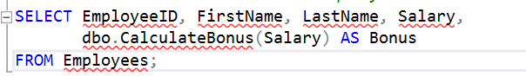

This will returns the following record with the calculated bonus:
